A Versatile Divide and Conquer Technique for Optimal String Alignment
David R. Powell, Lloyd Allison, Trevor I. Dix
Information Processing Letters, Vol. 70, Issue 3, pp. 127~139, January 1999
Abstract
In this paper we present a technique that can be applied to these algorithms to obtain an alignment using only linear space, while having little or no effect on the time complexity.
- Introduction
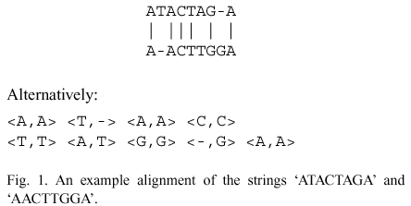
- The basic DPA
  - Dynamic programming algorithm(DPA)
Time: O(n^2), Space: O(n^2)
  - Alignment in O(n) space
Hirschberg’s algorithm
Time: O(n^2), Space: O(n)
  - Check pointing
Time: O(n^2), Space: O(n)
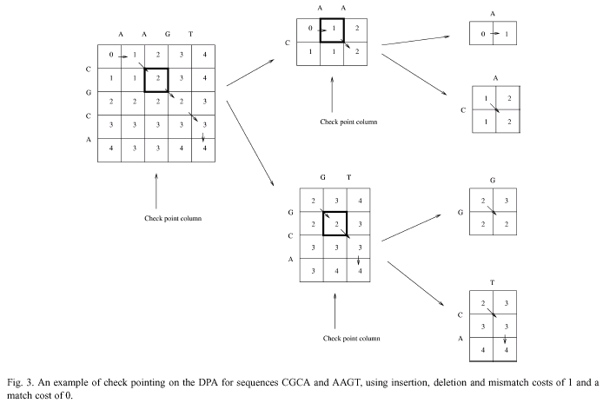
- DPA with linear gap costs
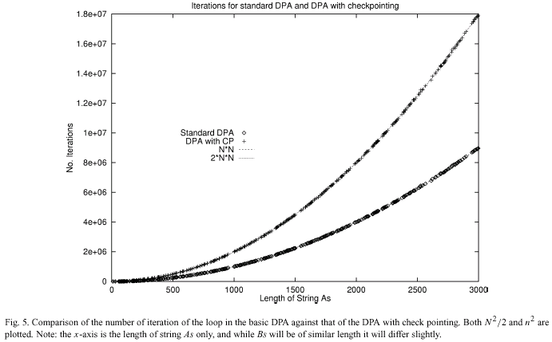
- Ukkonen’s algorithm
Time: O(n+d^2)
Alignment Space: O(d^2)
Cost Space: O(d)
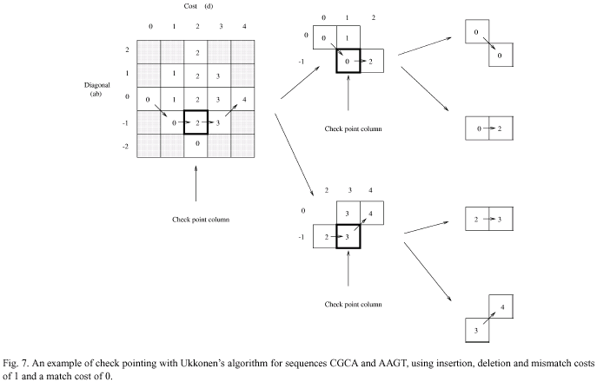
Created by: Chia-Mao Huang
Date: Mar. 28, 2000

